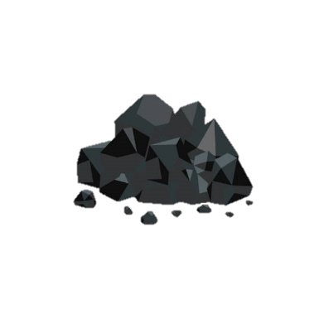 **“How Has Coal Mining Shaped Our Locality?” (Geography)**

**Vocabulary**

|  |  |  |  |  |
| --- | --- | --- | --- | --- |
| **city** | **coalfield** | **community** | **industry** | **land use** |
|  |  |  |  |  |
| **Very large town,** which often has a **cathedral.** | Region where **coal is under the ground**. | Group of people who **live in the same place**. | Businesses **making or selling similar products**. | Land used for a **specific purpose** or reason. |

**Important People**

**William Roy**

**(1726-1790)**

* Created the **Ordnance Survey map.**

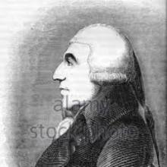

**Big Ws: Ordnance Survey (OS) Maps**

* Use symbols of **different shapes and colours**.
* They are meant to be easily **recognisable**.

**Doncaster**

**What I can remember**

|  |  |
| --- | --- |
| * **Tanzania (Y1)** | * **Our School (Y1)** |

**Big Ws: 8 compass points**

**Big Ws: Mining Communities**

**Big Ws: Types of Jobs**

|  |  |
| --- | --- |
| **Commercial**  **Money and trade (e.g., banking, insurance)** | **Construction**  **Creating buildings or human features.** |
|  |  |
| **Manufacturing**  **Making products from raw materials.** | **Retail**  **Business and shops that sell to the public.** |
|  |  |

**Big Ws: Land Use**

|  |  |
| --- | --- |
| **transportation** | **residential** |
|  |  |